**Database and Table Creation**

1. **Create Database and Branch Table**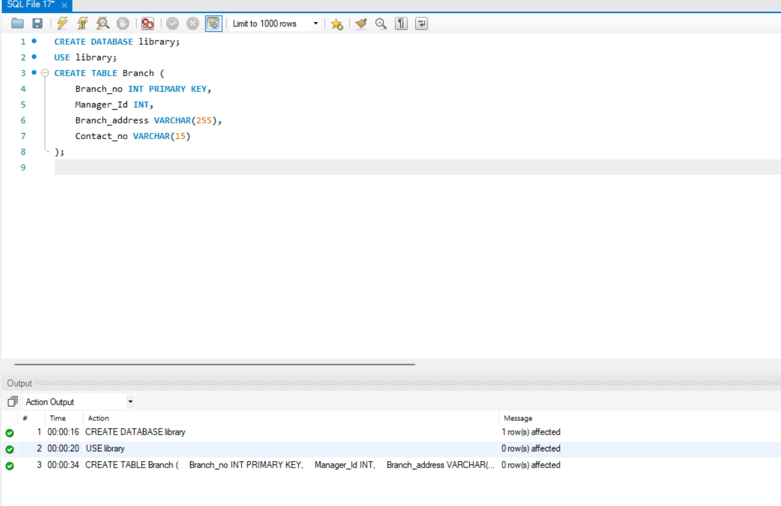
2. **Employee Table**:

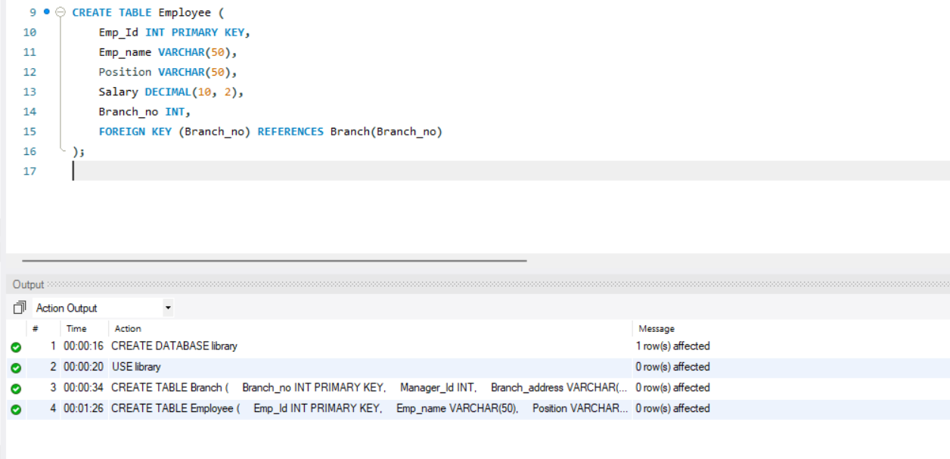

1. **Books Table**:

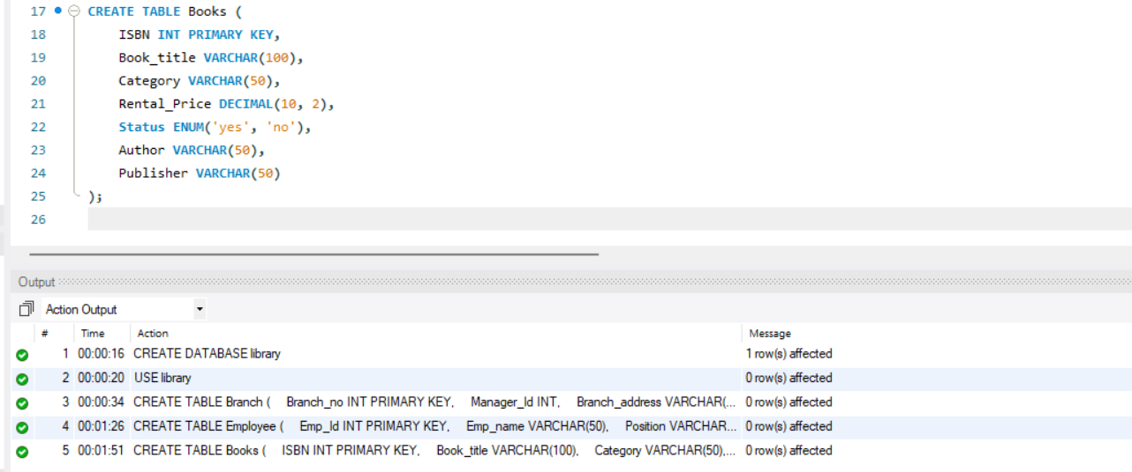

1. **Customer Table**:

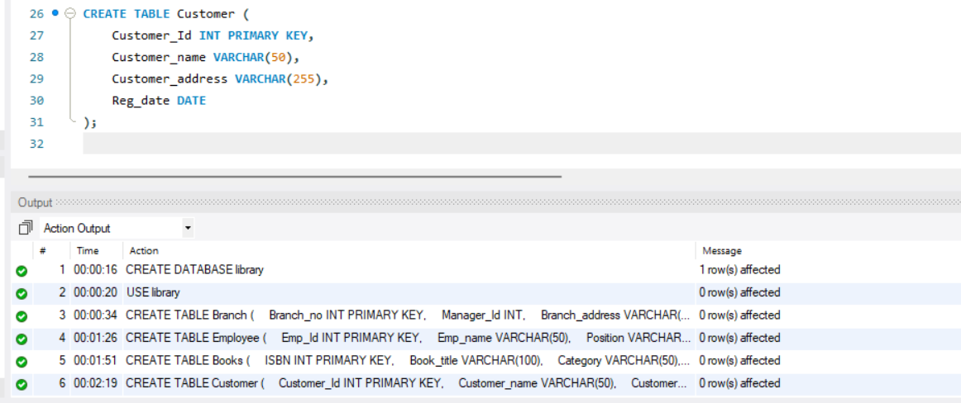

1. **IssueStatus Table**:

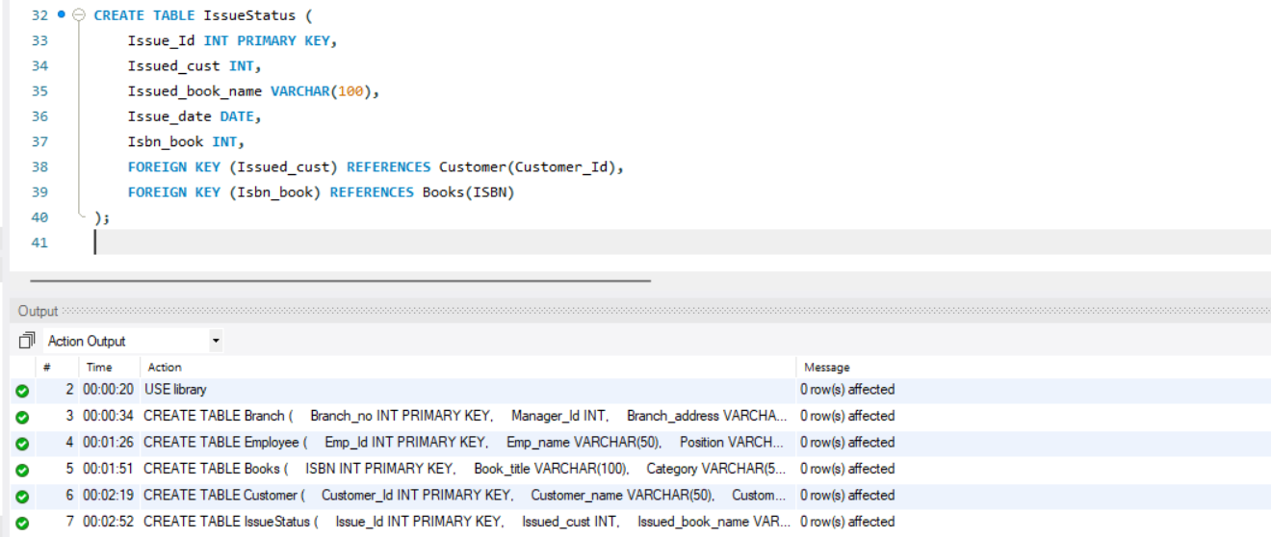

1. **ReturnStatus Table**:

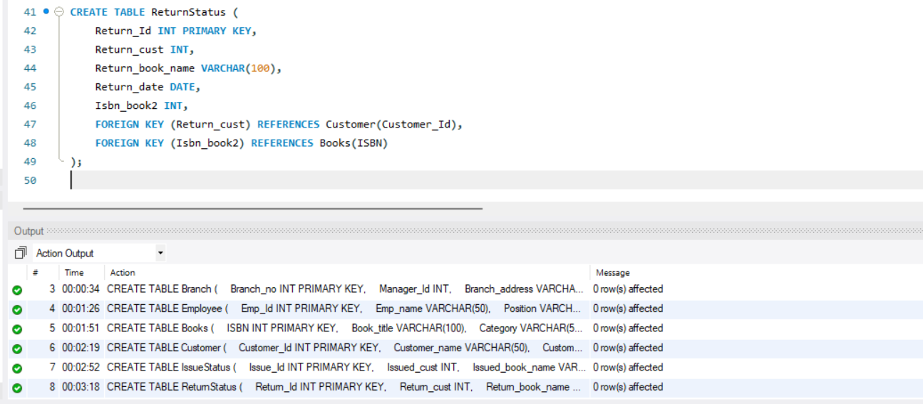

**Queries**

1. **Retrieve the book title, category, and rental price of all available books**:

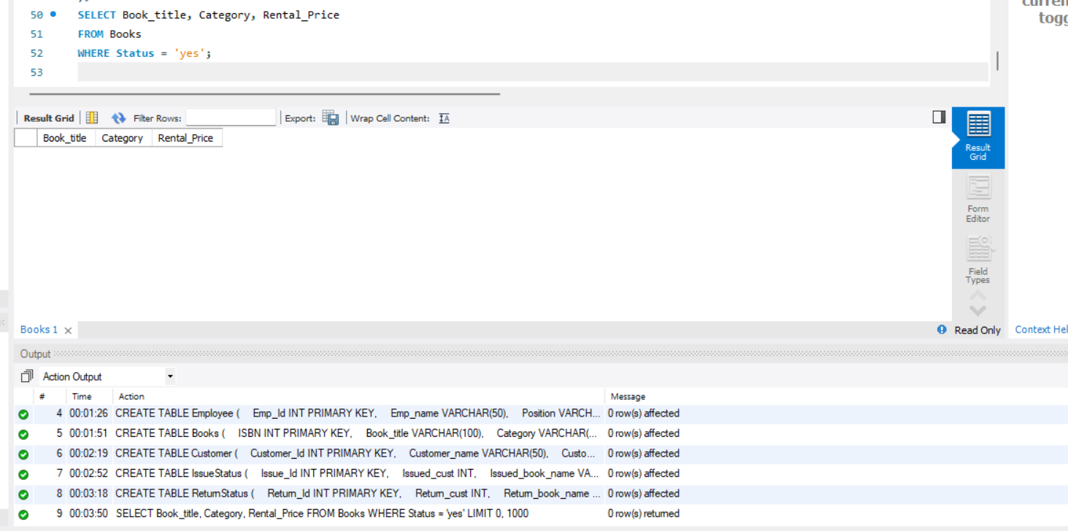

1. **List the employee names and their respective salaries in descending order of salary**:

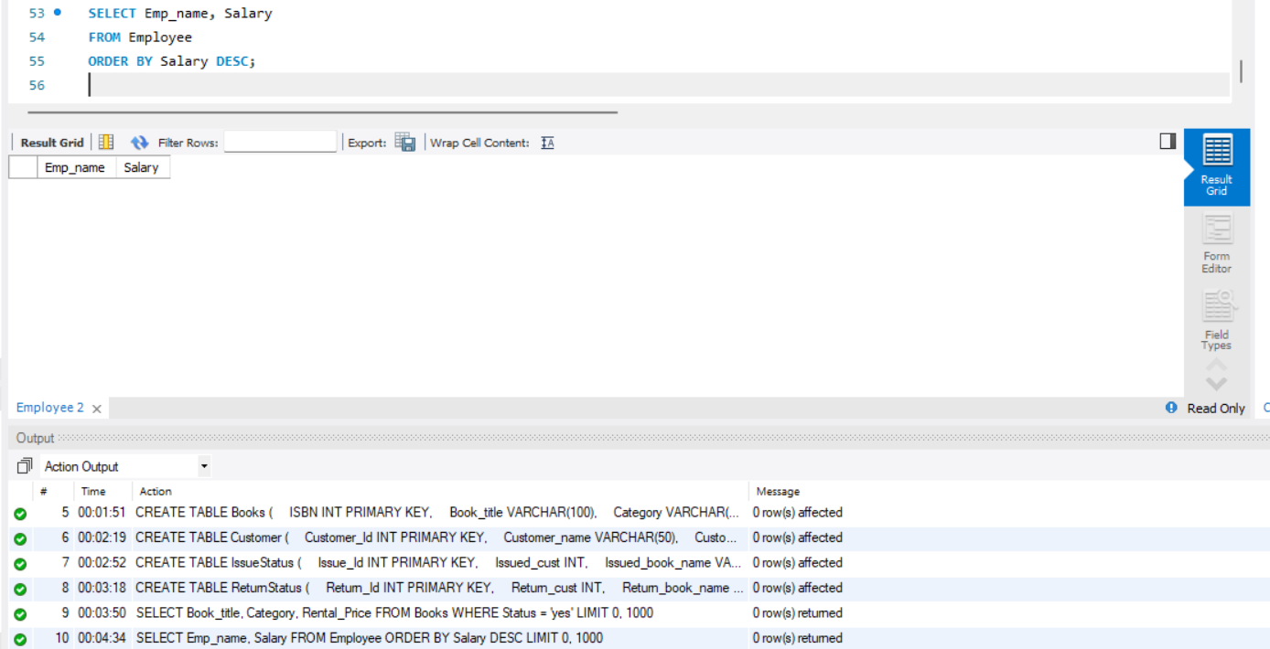

1. **Retrieve the book titles and the corresponding customers who have issued those books**:

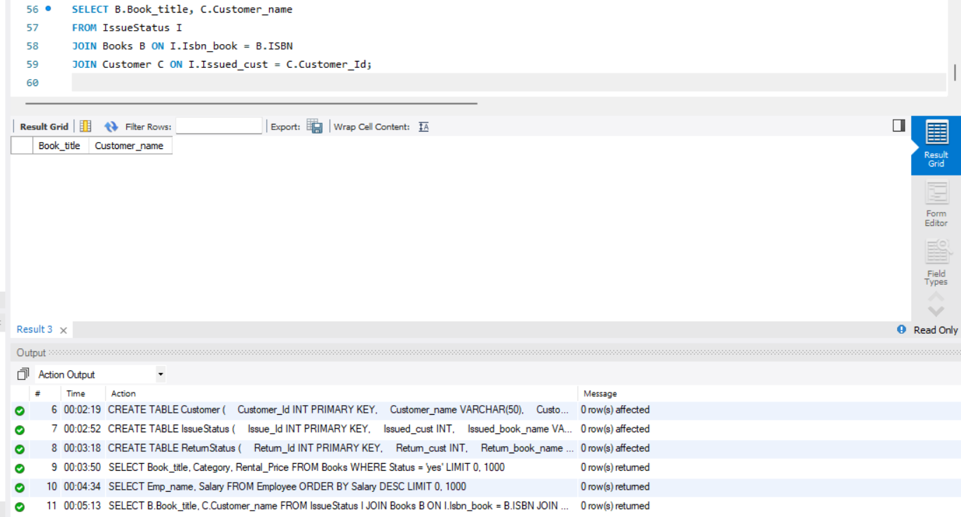

1. **Display the total count of books in each category**:

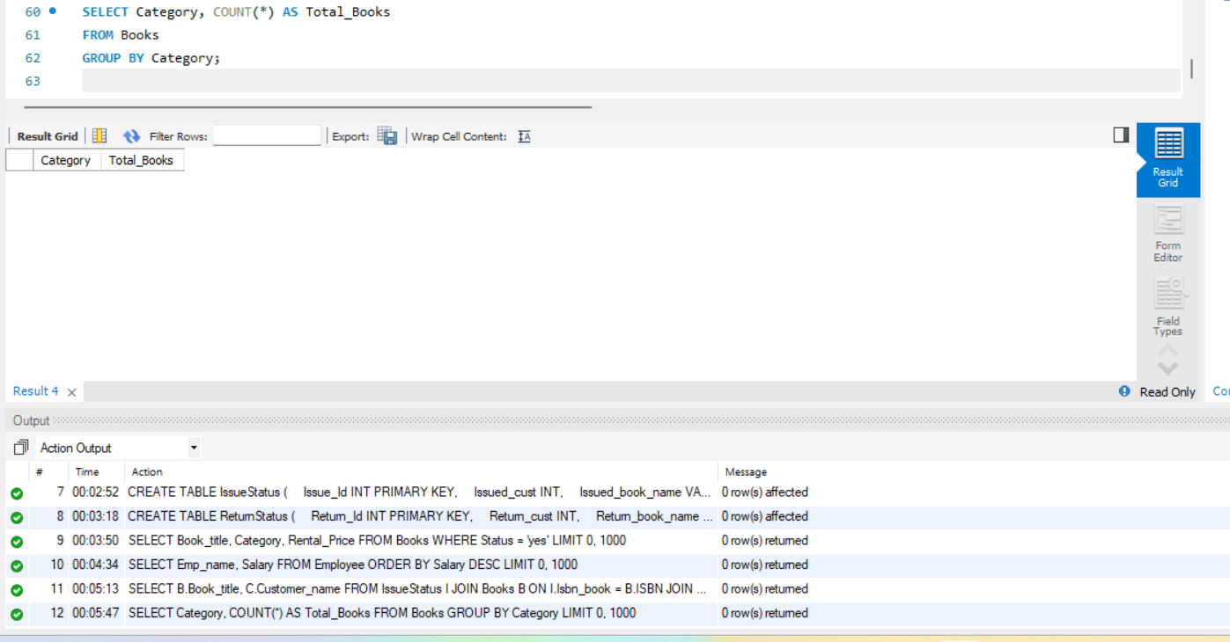

1. **Retrieve the employee names and their positions for the employees whose salaries are above Rs.50,000**:

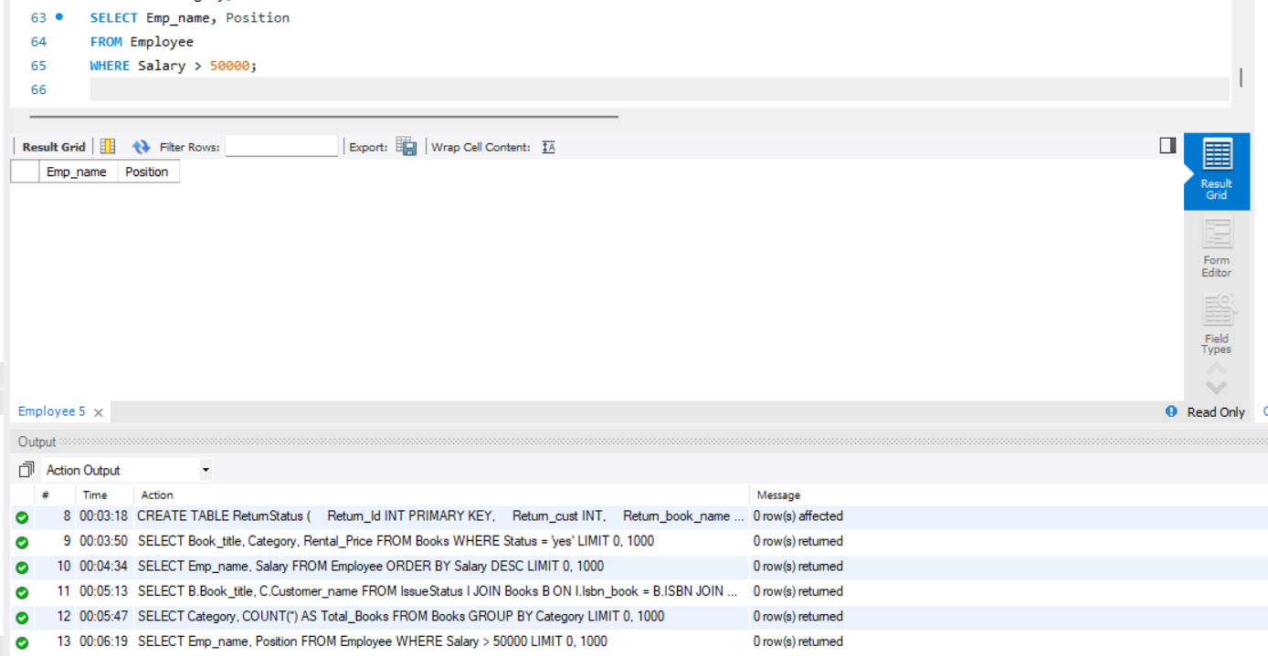

1. **List the customer names who registered before 2022-01-01 and have not issued any books yet**:

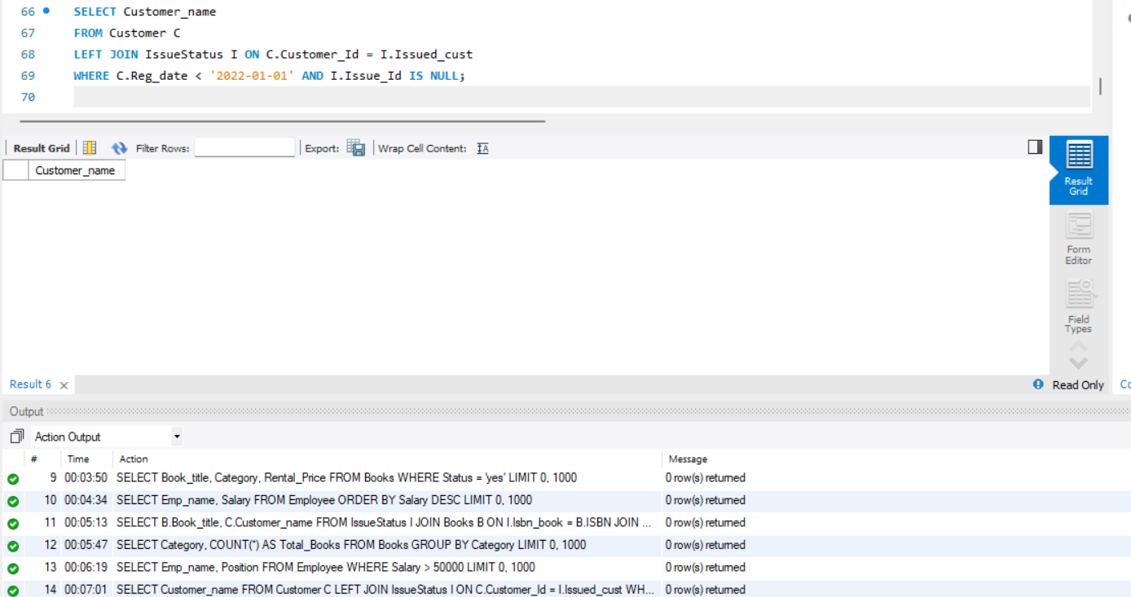

1. **Display the branch numbers and the total count of employees in each branch**:

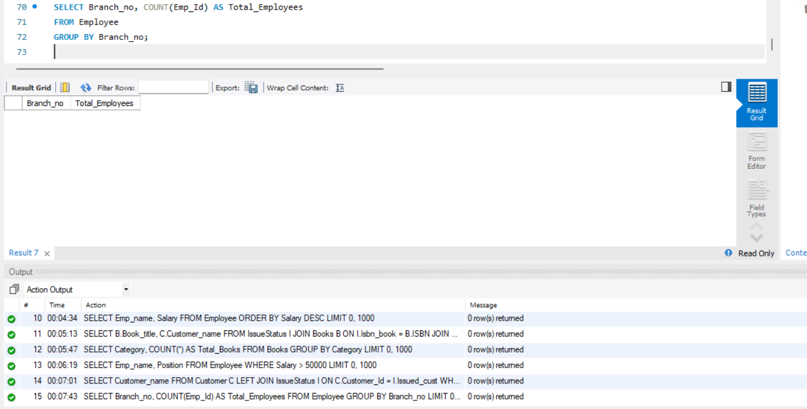

1. **Display the names of customers who have issued books in the month of June 2023**:

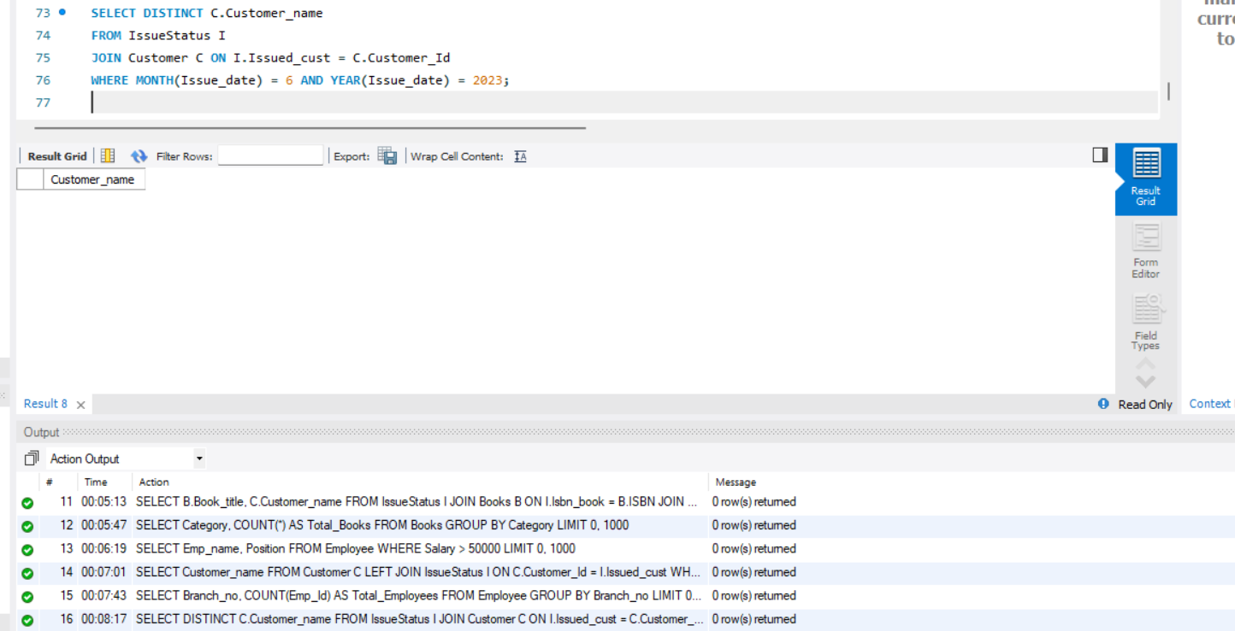

1. **Retrieve book_title from the Books table containing 'history'**:

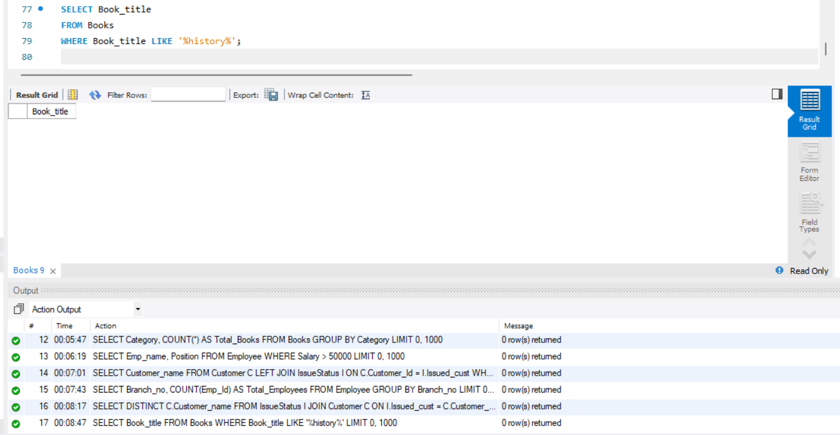

1. **Retrieve the branch numbers along with the count of employees for branches having more than 5 employees**:

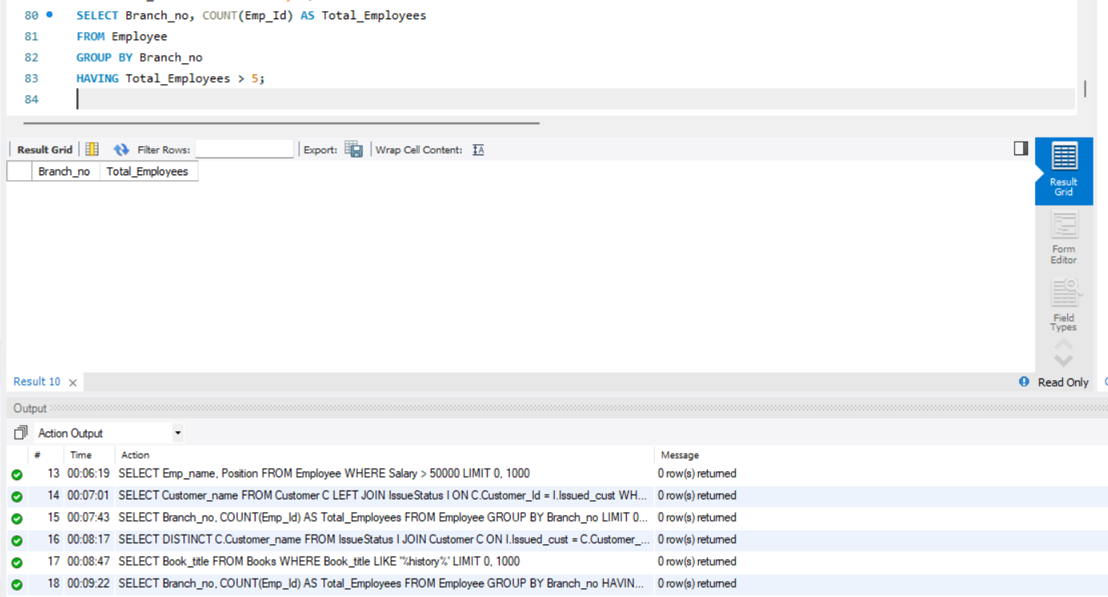

1. **Retrieve the names of employees who manage branches and their respective branch**

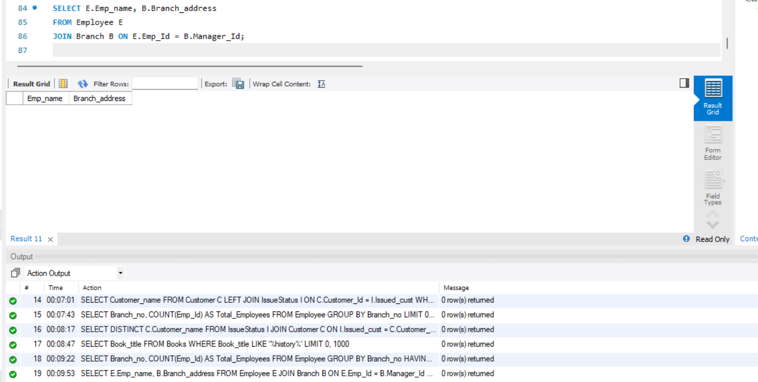

1. **Display the names of customers who have issued books with a rental price higher than Rs. 25**:

